  Report Name = REPORT_ANITHA_FA_CINEMATICKET
  Execution Time = 10/6/2022 4:52:26 PM
  User Name = CORPINDIA\EI13115
day | Film Type | cinema code | tickets sold | ticket price | month | day
1 |  |  | Total=740
2 |  |  | Total=855
3 |  |  | Total=714
4 |  |  | Total=525
5 |  |  | Total=233
6 |  |  | Total=272
7 |  |  | Total=608
8 |  |  | Total=562
9 |  |  | Total=376
10 |  |  | Total=440
11 |  |  | Total=894
12 |  |  | Total=1423
13 |  |  | Total=647
14 |  |  | Total=679
15 |  |  | Total=1995
16 |  |  | Total=560
17 |  |  | Total=857
18 |  |  | Total=821
19 |  |  | Total=1050
20 |  |  | Total=559
21 |  |  | Total=476
22 |  |  | Total=1657
23 |  |  | Total=372
24 |  |  | Total=736
25 |  |  | Total=532
26 |  |  | Total=713
27 |  |  | Total=307
28 |  |  | Total=300
29 |  |  | Total=1014
30 |  |  | Total=451
31 |  |  | Total=667

 |  | 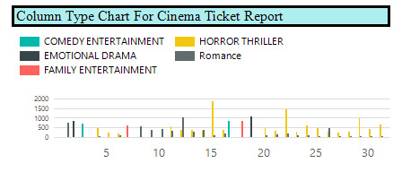
 |  | 